Electrode materials in the oxidation of rhodanide

Kosohin O.V., Kushmyruk A.I., Linyucheva O.V.

Igor Sikorsky Kyiv Polytechnic Institute, Kyiv, Peremohy prosp., 37, 03056

Rodanides (thiocyanates, salts of thiocyanate acids) are widely used in industry, in particular, for the synthesis of thiourea, in analytical chemistry, in agriculture as toxic chemicals. However, during the oxidation of rhodanides, the formation of cyanide (hydrocyanic) acid is possible, that requires monitoring the implementation of the processes of using rhodanides. However, controlled oxidation reaction [1]
, (1)
can be a source of trace amounts of hydrogen cyanide and can be used to test diagnostic tools for cyanide in environmental monitoring systems in industries, which related to the possible release of hydrocyanic acid into the air of the working area. These include, first of all, the production of acrylonitrile, the extraction of precious metals from raw materials, galvanic processes. However, any diagnostic tools (gas analyzers) require periodic testing, which requires the availability of means of calibration – metering devices of standard gas mixtures. Such mixtures of hydrogen cyanide in Ukraine are not produced, and their transportation is potentially dangerous, given the significant toxicity and explosion hazard. That is why the creation of a air-gas generator that would allow controlled generation of the required amount of hydrogen cyanide at the time of testing gas analyzers is of considerable interest.
1. Experimental
In work as an electrode material and conductive base is used titanium in the form of a PTEM grade powder with a dispersity of 0.05...0.10 mm; wire with a diameter of 1.5 mm and foil with a thickness of 0.1 mm (titanium grade VT1-0). The preparation of titanium consisted in etching with a 30 % solution of H₂SO₄ to remove impurities of heavy metals, followed by washing with running and distilled water.
A catalytic platinum coating on a titanium base was obtained by thermal decomposition of hexachloroplatinic acid, the calculated amount of which was applied to the surface of titanium and evaporated, after which it was calcined for an hour in a muffle furnace at an acid decomposition temperature [2]:
The calculated amount of platinum was 30 mg of catalyst per 1 g of Ti.
Electrodes based on powdered titanium were made in the form of discs with a diameter of 18 mm and a thickness of 0.25 mm by pressing. To the electrodes were pressed into the current lead of tantalum wire. The final pressing pressure was 360 MPa, which exceeds the yield strength of titanium. We used molds from tool steel U-8, and as a press, an IP-100 type machine with an electronic control unit.
The study of the effect of pH on the behavior of electrode materials in solutions of rhodanide was carried out at a constant pH value, which was set by adding the calculated amount of sulfuric acid to a solution of potassium rhodanide. The pH of the solutions was determined using an I-150 ion-meter.
The study of the behavior of titanium and electrodes based on it in potassium rhodanide solutions was carried out in a potentiodynamic mode using a standard three-electrode cell with separated cathode and anode spaces. An Ag/AgCl electrode filled with a saturated KCl solution was used as a reference electrode, its potential relative to the standard hydrogen electrode was 0.225 V. The auxiliary electrode was made of 0.2 g of titanium powder, activated by platinum, and pressed onto a disk of 2 g of titanium. The electrodes were connected by current leads with the corresponding contacts of the potentiostat PI-50-1.1 with the programmer PR-8 and the two-coordinate potentiometer PDA 1-01. The potential sweep rate in the potentiodynamic mode was 2∙10⁻³ V/s.
2. Results and discussion
Titanium, despite the strongly negative potential for ion formation reactions, is characterized by high corrosion resistance in many corrosive environments, which is explained by significant passivation [3]. In solutions of sulfuric acid with a pH 0.1...3.0, a current-free potential of +0.1...+0.4 V is set on the surface of titanium for flat and wire electrodes and +0.3...+0.5 V for powder titanium electrodes. The magnitude of the potential is due to the processes of ionization of oxygen dissolved in the electrolyte on the surface of titanium.
2Н₂О = О₂ + 4Н⁺ + 4е, Е = 1,23 – 0,059рН. (2)
and a change in the thickness of the oxide film with a simultaneous change in the phase composition of the oxide layers
, Е = -0,091 – 0,059рН. (3)
A higher potential value for electrodes made from titanium powder is associated with a higher concentration of oxygen, which remains deep in the pores of the electrode when it is impregnated. In solutions with a lower pH value, a slower steady-state establishment of the potential was generally observed.
The anodic polarization of titanium (Fig. 1) leads to the appearance of currents associated with an increase in the thickness of the oxide layers according to reaction (3). The degree of surface extension practically does not affect the current density, which is calculated on the apparent geometric surface. This indicates an insignificant contribution of the deeper electrode layers to the current-forming processes.
In solutions with a lower pH value, the anode currents had a greater value, but did not exceed 2.5∙10⁻⁵ A/cm², which indicates a high stability of titanium in the investigated pH range in solutions of sulfuric acid.
In a solution of potassium rhodanide with a concentration of 1 M (pH 6), the current-free potentials of +0.1...+0.3 V are set on titanium, which indicates the occurrence of conjugate reactions (2) and (3). The type of anodic polarization curves up to a potential of 0.75 V indicates the inertness of titanium in this solution (Fig. 2, a). The potential for the appearance of current corresponds to the reaction of formation of cyanogen [4]
, Е⁰ = 0,77 В, (4)
which in the aquatic environment quickly hydrolyzes
. (5)

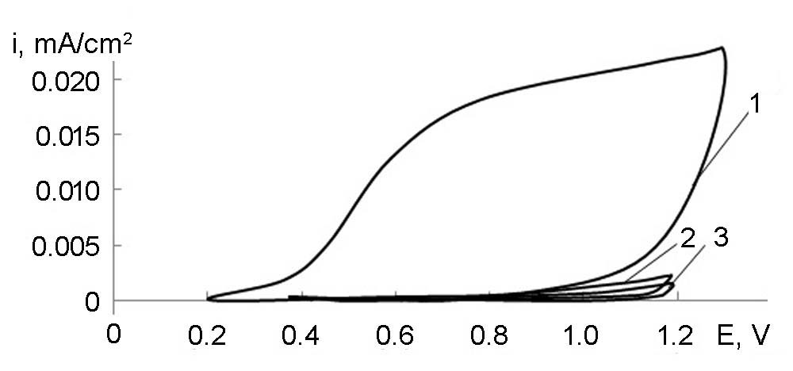
Fig. 1. Polarization curves in a solution of H₂SO₄, pH 1, on titanium electrodes of various types: 1 – wire; 2 – porous; 3 – plate.

However, the current density did not exceed 0.25 mA/cm² at a potential of 1.0 V, regardless of the extension of the electrode surface.

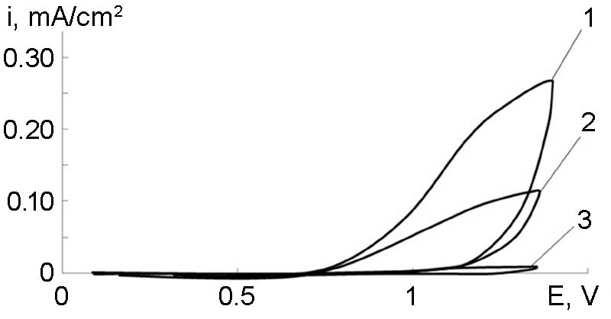 | 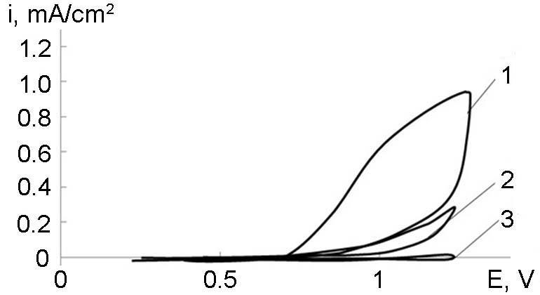
а | b
Fig. 2. Polarization curves in 1 M KSCN with pH 6 (a) and pH 1 (b) on various types of titanium electrodes: 1 – wire; 2 – porous; 3 – plate.

In solution of potassium rhodanide with pH 1, the anodic currents, which may caused of the oxidation of the products of the conversion of thiocyanate, are several times higher than at pH 6 (Fig. 2, b), which is associated with the greater completeness of the reactions (1), (4) and (5). However, the values of these currents do not exceed 1 mA/cm², which confirms the suitability of titanium as a conductive electrode base for the oxidation of rhodanide to +1.0 V.
The data of the Fig. 1 and 2 show that the currents on the electrodes of various types increase in the following sequence: plate – porous – wire. The ratio of two quantities was calculated – the area of the electrode in contact with the solution and on which all processes actually take place, to the volume of the electrode (see table). There is a correlation between the obtained parameter and the direction of the increase in currents. The smallest value of this parameter, which actually represents the length of the passage of electrons from the reaction zone to the point of the collector, is observed on the wire electrode. Thus, the smaller the current path, the more equipotential the electrode surface is, and consequently, large values of current can be achieved.
Tablе. The influence of the type of electrode on the ratio of the electrogenerating area to the volume of the electrode
Parametr | Type of electrode
 | wire | porous | plate
Area, S, см² | 9.4 | 10.2 | 2
Volume V, см³ | 3.5 | 2.5 | 0.2
Ratio S/V | 2.7 | 4 | 10

On titanium, activated by platinum, in solutions of sulfuric acid, current-free potentials of 0.7...0.75 V are established, which are close to the potential of the reaction
, . (6)
The anodic polarization of such an electrode leads to the appearance of anodic currents (Fig. 3) associated with filling the surface with adsorbed oxygen and the formation of platinum oxides of greater stoichiometry:
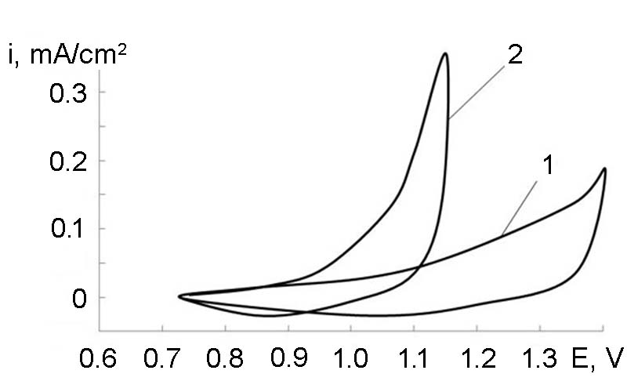 | 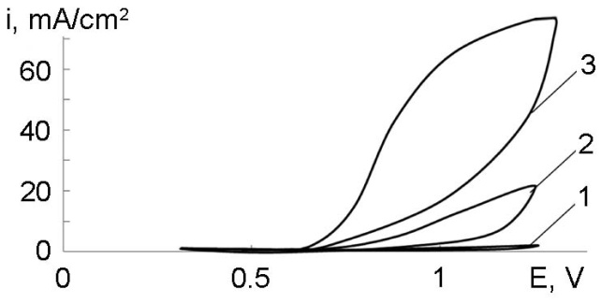
Fig. 3. Polarization curves on titanium, activated by platinum, in a solution of H₂SO₄ (pH 1): 1 – porous electrode;  2 – wire electrode. | Fig. 4. Polarization curves on a platinum-activated titanium electrode in a solution with a pH 1 and a KSCN concentration, M: 1 – 0; 2 – 0.1; 3 – 1.
, Е = 0.98 – 0.059рН, (7)
, Е = 1.018 – 0.059рН. (8)
In this case, as for titanium, the use of a wire electrode makes it possible to achieve large values of anodic currents (curve 2, Fig. 3).
The introduction of potassium rhodanide into the solution of sulfuric acid leads to the appearance of currents of rhodanide and adsorbed sulfur on the anodic curve at a potential of + 0.65 V (Fig. 4)
,
which is formed as a result of the decomposition of the acidic form of thiocyanate acid:
.
Increasing the concentration of potassium rhodanide allows to obtain high values of currents under conditions of anodic polarization. It should be noted that the behavior of platinized titanium is similar to the behavior of pure platinum (Fig. 5), with the exception of smaller values of anode currents.

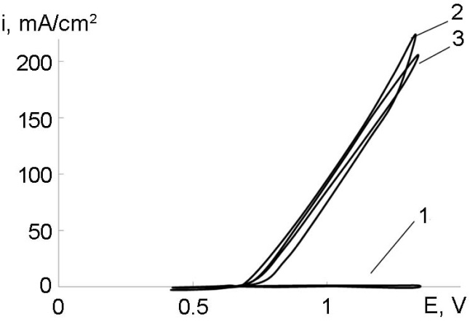

Fig. 5. Polarization curves on platinum electrode in a solution 1 – Н₂SO₄ (рН 1);
2 – 1 M KSCN (рН 1); 3 – 1 M KSCN (рН 6).

3. Conclusion
Titanium exhibits significant inertness in solutions of sulfuric acid with a pH 0.1...3. In equilibrium, conjugated processes of ionization of dissolved oxygen and an increase in the stoichiometry of titanium oxides occur on the surface of titanium. Anodic polarization of titanium in a solution of sulfuric acid led to the appearance of currents of no more than 5∙10⁻⁵ A/m², which indicates the absence of its anodic activity.
The introduction of potassium rhodanide into a solution of sulfuric acid leads to the appearance of anodic currents at potentials above 0.75 V, which indicates a slight activity of titanium in the reactions of oxidation of rhodanide. The shape and degree of extension of the electrode surface are of great importance for the choice of the type of electrode – large current values are achieved on wire electrodes due to a more uniform distribution of potential.
The surface activation of titanium with platinum made it possible to obtain electrodes stable in acidic solutions with a low overvoltage of the oxidation reaction of rhodanide, which in their electrocatalytic properties are almost as good as platinum.
Thus, it has been shown that titanium activated platinum can be used as the anode material of an electrochemical generator of "hydrogen cyanide – air" mixture.
References
[1] Z. Tocksteinová, F. Opekar, The electrochemical generation of small amounts of hydrogen cyanide // 1986. Talanta 33 (8), 688-690 pp.
[2] A. E. Schweizer, G. T. Kerr, Thermal Decomposition of Hexachloroplatinic Acid, Inorg. Chem. 17 (1978), 2326–2327 pp.
[3] M.N. Fokin, Yu.S. Ruskol, A.V. Mosolov, Titan and its alloys in the chemical industry: reference book, Leningrad, Chemistry, 1978, 200 p.
[4] O. Barbosa-Filho, J. Monhemius, Leaching of gold in thiocyanate solutions. Part 1: Chemistry and thermodynamics, Transactions Institution of Mining&Metallurgy 103 (1994), 105-110 pp.

